**Pregnancy After Age 35 and Pregnancy at the Age 45 and After 45**

The era has come where youngsters have clear thoughts in mind about how their future life would look like. We get immensely into business that we keep our personal life at pause. Well, there’s a certain thrill involved too. Personally, I won’t call getting pregnant after 35 years an ‘old age pregnancy’. It depends purely on the couple.

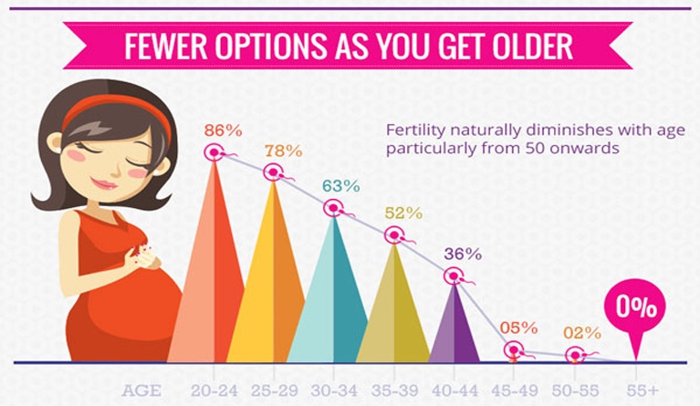

**Are you sure about getting pregnant after 35 years?**

If you think you want to have a baby, no time is wrong! Scientifically, if you are still ovulating and haven’t reached menopause yet, you can conceive and enjoy pregnancy after age 35. For obvious reasons, a woman’s body becomes weaker as compared to men. And therefore, some things need to be pointed while opting pregnancy in old age or pregnancy after age 35.

* Be emotionally prepared.

Make sure you don’t stress about what people might say or ask. It’s your life and your decisions are going to make a difference for you! Pregnancy after age 35 must not bother you.

* Take proper Prenatal care.

Visit a doctor and ask for certain medications required before getting pregnant after 35 years. It will include screenings, health check-up, some regular examination, important education and mental support. Some check-ups because of pregnancy after age 35 might be added.

* Extra care for extra years passed.

This old age pregnancy doesn’t stop you from being happier and healthier. Some extra care prescribed by doctors must be followed passionately for pregnancy after age 35.

* Cover nutritional gaps.

Make sure you take a healthy balanced diet and maintain a healthy environment around you before this old age pregnancy to skip any health-related complications.

**To-Do List**

You must have been wondering about medications you need to take while getting pregnant after 35 years. There might be potential risks of being pregnant at 35 years and above that might degrade your body or do worse. Nothing to worry before a doctor’s appointment! Don’t loose hope and follow the list to fulfil your wishes of getting pregnancy after age 35.

* Be regular seeing your doctor

Never miss a doctor’s appointment specially when you are dealing with pregnancy in old age. There might be some highs and lows in pregnancy after age 35 that needs to be concerned on time.

* Eat satisfactorily

Make a diet plan and fill your tummy with nutrition. A happy stomach will keep your mind fresh and tension-free during pregnancy after age 35.

* Gain recommended weight

Don’t fear if you are gaining weight. You will carry a whole human specie in your womb! The baby will take away the weight he/she is bringing. Ask your doctor for a scheduled healthy weight gain chart.

* Don’t forget exercising!

Exercising keeps you strong. There are some specialised exercises recommended for pregnant women to increase their body strength and helps them fight minor diseases especially during pregnancy.

* Mark vaccination dates

Never ever miss vaccinations for a normal child growth during pregnancy after age 35. Give your young one the care he/she deserves.

* Sleep soundly

Relax your body and take a nice sleep of at least 7-8 hours a day during pregnancy after age 35.

* Maintain good hygiene

Make sure the area you are surrounded with is clean and hygienic. The washroom used is well maintained and disease-free during pregnancy after age 35. These small things add up in making a better ecosystem for you and your baby.

* Dispose off smoking and drinking habits

These things oppose health and become obstacles for pregnancy in old age. Avoid them!

* Avoid taking unnecessary stress



**Risks of being pregnant at 35 years and above**

As we get older, fewer eggs are released by ovary and they aren’t easily fertilized during sex. Also, few risks of getting pregnant at 35 and above can be avoided if you are a health keeper! While some younger women may witness complications, risks of being pregnant at 35 years and above are higher. These include:

* High blood pressure
* Preeclampsia
* Higher glucose levels
* Gestational diabetes

But these problems can be cured timely. If your agenda is firm, you’ll find a number of ways to tackle the problems. Enjoy pregnancy after age 35!